Finding Plots Without Horizon Data
Create a new query and include the env, humus, and mineral tables
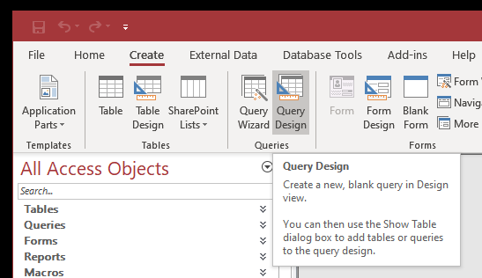
Double-click the line between the env and humus table. Select option number two, all records from env and just the matching humus records.
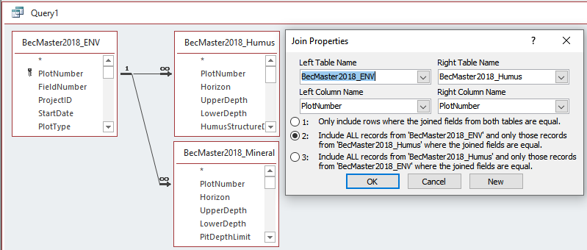
Double-click the line between the env and mineral table. Select option number two, all records from env and just the matching mineral records.
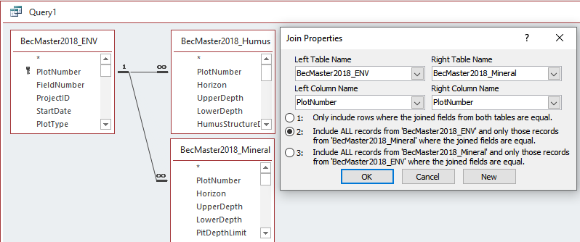
These criteria will find plots missing both humus and mineral horizon data.
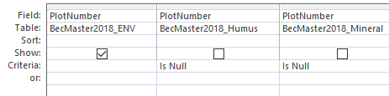
These criteria will find plots with either humus or mineral horizon data missing
